5
Belt and Road Initiative of China

F
or China, the sustained growth is becoming a major challenge, as it is faced with both current and capital accounts surplus. China has endeavored to transform its growth model from investment and export model to consumption and domestic demand based economy. Under the “New Normal” philosophy of President Xi Jinping for high and sustained growth, the Belt and Road Initiative (BRI) was kicked off in 2013 under China Dream of Grand Rejuvenation. This is continuation of the Opening up policies of modern China, which will serve as grand strategy for transition during 2013-2050.
China has highlighted its five reforms priorities under BRI during this period

i. Policy coordination
ii. Unimpeded and uninterrupted global trade
iii. Facilitating Connectivity
iv. Financial Integration
v. Bonds between the people

The BRI is manifested in long term mega investment in the infrastructure development projects to connect the China with international markets in Asia and Europe. The BRI is comprised of overland and maritime routes as given on next page.
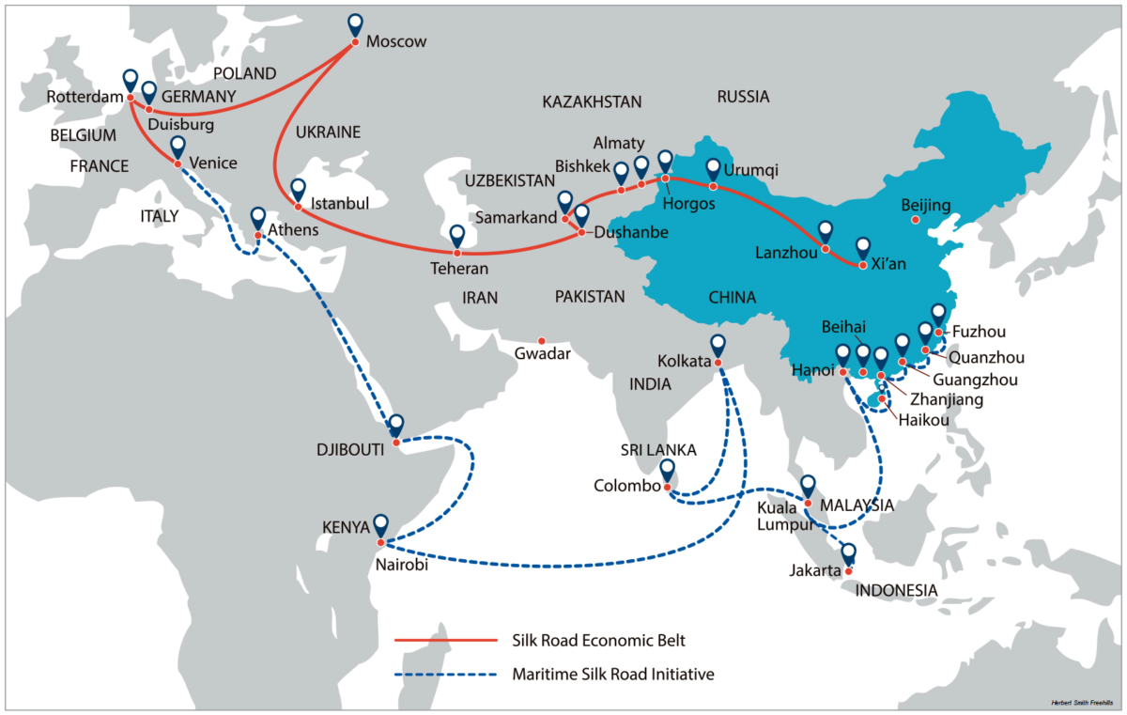

Hideo Ohashi (2018) The Belt and Road Initiative (BRI) in the context of China’s opening-up policy, Journal of Contemporary East Asia Studies, 7:2, 85-103.

For China, Maritime Silk route was always an important connectivity with the rest of the world, however during the Cold War, its importance remained defused one way or the other way. China initially announced the One Belt One Road (OBOR) to provide transport corridors to facilitate access to foreign markets and increase the turnover of goods transported from China to Europe and adjacent regions through Central Asia. The region of Central Asia includes Afghanistan, Kazakhstan, Kyrgyzstan, Mongolia, Tajikistan, Turkmenistan, Uzbekistan, and also vast territories of India, Iran, China, Pakistan and Russia. Later in 2015, its name was approved as Silk Road Economic Belt and the 21st Century Maritime Silk Road in the meeting of National Development and Reforms Commission in 2015. This projects will connect at least 65 countries of the world, which constitute 70% of the world population. The BRI in its dimension, purpose and objectives goes back to Great Silk Road, connecting East and West. The Silk Route Economic Belt (SREB) is comprised of three important parts:
- The Northern Corridor, or the New Continental Bridge to St. Petersburg and Helsinki through Kazakhstan and Russia with the possibility of extension to Rotterdam;
- The Central corridor through Central Asia, which then branches into several directions: to Western Asia and the Persian Gulf, to Mediterranean countries (Turkey, Italy), and also to Western Europe (the port of Rotterdam);
- The Southern Corridor through the regions of South-East Asia and South Asia to the largest ports of Pakistan and Indonesia allowing easy access both to Indian and Pacific oceans.

The objectives of the BRI and SREB are further highlighted as follows:

          - Increasing exports for sustained growth of China, by exploring new markets of Central Asia, South Asia and Europe
          - Diversification of China’s trade routes and reducing dependence on USA
          - Access to fuel and Energy resources of Central Asia
          - Increase of Foreign Direct Investment (FDI) in Chinese Companies
          - Smoothening and levelling of economic development of the underprivileged regions of the country.

The old Silk Route was developed about two thousand years back in the Hans Dynasty and the new Silk Route also called as Belt is aimed at creating thickly integrated and intertwined trade corridors which will ultimately lead to regional economic integration. Some western analysts declared it like US Marshall Plan but the difference is that it is not based on any foreign aid or Foreign Direct Investment but rather a loan financing by China Infrastructure Development Bank. With the new Silk Route, China desires to become an economic power through a new economic world order. Along the new Silk Route, China wants to achieve five bonds in the region. First close coordination and integration of the countries along the BRI. Second building required infrastructure such as roads, railways, harbors, bridges etc. Third exchange of knowledge in the modern technologies and emerging fields of Information and communication technologies and material sciences. Fourth to enhance collaboration in the financial sector. Finally, people to people exchange, leading to building common identity along the Silk Route.
The BRI is faced with the internal and external security challenges. Internally, the strategic threats to China will surface when it is connected to the Strait of Malacca which connects the China Sea and Burma Sea, through Bay of Bengal. Externally the Belts has to pass though unstable regions such as Afghanistan and Central Asia. The construction of huge physical infrastructure will also create serious environmental challenges. BRI and its extension will lead to creating a multipolar world, thereby reducing the US influence on global strategic decision making.

At least the following six corridors are proposed under BRI:

1. China–Mongolia–Russia economic corridor
2. New Eurasia land bridge economic corridor
3. China–Central Asia West Asia economic corridor
4. China–Pakistan economic corridor
5. Bangladesh–China India–Myanmar economic corridor
6. China–Indochina economic corridor.

The West is considering the policies of China under New Normal as their fight for hegemony in the Central Asia. For developing countries of the region, with limited resources for their infrastructure building and maintenance, BRI will prove a golden opportunity to connect with the international market. Such infrastructure investment by China will stimulate the global trade and growth.
BRI is a very optimistic approach of China for regional and global trade integration but it is faced with multitude of Challenges. The digital growth in the world and exponential development of Information and Communication Technologies (ICTs), have created significant global economic growth. The Industry 4.0 revolution is using these technologies for effective and efficient manufacturing processes and production. China has developed homemade industrial policy called Made in China 2025, to improve hi-tech developments for global market. The concept of Industrial internet adopted by China incorporates the industrial innovations of China in different processes of industry and encourages progress and competitiveness of the real economy to create a new, more comprehensive form of economic growth. This action and roadmap for industrial and trade growth provided elven guidelines actions for entrepreneurship and investment, which include e-commerce, industrial cooperative, inclusive finance, public service, efficient logistic, efficient transport, green ecology, modern agriculture, Artificial Intelligence (AI) and clear departmental responsibilities (The State Council, 2016). The digitalization of BRI has been manifested in the following major developments:

i. Rapidly rising Digital networking
ii. Exponential rise of ICT in China

With the BRI digital assistance to the region, China will ultimately govern the BRI countries through technology and infrastructure, however international rules will be required for BRI nations and region. Some of the challenges along the digital BRI, include tensions between cultures, ideologies of philosophy, cyber terrorism, and cybercrimes, personal security and privacy will be threatened.
China Pakistan Economic Corridor is shrouded with mysteries and myths in Pakistan and world, yet it is considered a Destiny Changer. The international border between China and Pakistan is stunning at 4,693 meters above mean sea level at the Khunjarab pass in Karakoram in the North of Pakistan. CPEC, as part of 21st Century Mari-time Silk-road at Sothern Corridors. Various roads, sea and rail routes along CPEC are given in Fig . The route was first proposed by Chinese Prime Minister Li Keqiang during his visit to Pakistan in 2013. The important projects on CPEC include US$33 billion worth energy projects like solar, hydroelectric power projects which will inject 10,400 Megawatts electricity in the national grid, hydropower projects and coal. The second important component of CPEC is to improve and strengthen the transportation and communication network between China and Pakistan. This component will cost about $11 billion. These components also include fiber optic cable from Xingjiang China to Rawalpindi Pakistan , 1240 km long Karachi-Lahore motorway, metro and bus service in six major cities, up gradation of 1300 km long Karakorum Highway, gas/oil pipelines to connect Kashgar to the seaport of Gwadar, 1800 km railway line, commercial sea-lanes, special economic zones (SEZs), dry ports and other infrastructure. An important component of CPEC is Gwadar port which has already been leased out to China for 40 years. The connection of Gwadar port with the road networks and China, would reduce the distance between China and Middle East and Europe by about 4500 nautical miles, as Gwadar is very closely located to International Sea Line Of Communications (SLOCs) and being a deep sea port protected from disasters. It can be used for show-casing and storage of sea resources, shipment, trans-shipment, and manufacturing conveniences for regional and extra-regional key players, as well as for UAE, Gulf States and European nations. During his first visit to Pakistan by President Xi Jinping categorically said: ´Friendship between China and Pakistan is based on trust and mutual support, and we have been devoted friends through both good and hard times. Our friendship is a pacesetter for amicable relations…” A total of 51 agreements were signed between the two countries with an initial investment commitment of $ 46 billion, which has been raised to $62 billion at present.
Bilateral trade between Pakistan and China started as early in 1962 and in 2006, Free Trade Agreement was signed between the two countries. The first mega project financed by China in Pakistan was construction of Karakoram Highway back in 1960s. CPEC will bring many opportunities for Pakistan, which are briefly given as follows:

i. Employment creation in Pakistan: There is a general apprehension that the CPEC will generate employment in different sectors from manufacturing to services. It has been reported that about 400,00 jobs have been created on construction project for local skilled and semi skilled human resource by 2018. China is moving from labor intensive industries with high value addition manufacturing and due to high wages in the competitive markets, there are chances for Pakistan to attract FDI in the textile sector, as well as strong clusters in sports goods, surgical instruments and light engineering.

Strengths of CPEC projects for Pakistan and China:
- The strategic location of Pakistan for Asian countries and Europe as well it long physical connection with China offer a strength for CPEC. The close proximity of Pakistan to Gulf, middle east and Arabian Sea makes it a uniquely located country, where 40% of the Oil and Gas imports and exports take place along its coastal line.
- With large population, 6th in the world and 2nd in the Islamic countries, Pakistan offers a large consumer market. At present about 60% of population is comprised of youth, which can be used as modern IT enabled skilled labor for the economic transformation.
- Due to deep seaport, Gwadar offers large capacity for the ship. The depth of seaport is highest at 18 meters and ships capacity of 120, making it largest in the region as against Qatar and Iran Charbahar seaports.
- Shortening of the trade route with CPEC, will reduce the it to 1/3rd.
- Pakistan can get the expertise from China in emerging technologies like Artificial Intelligence (AI), robotics, Renewable Energy, agriculture, biotechnology. This will involve training of youth in these areas.

Some of the threats to the success of CPEC include:

- The regional security concerns both in the Southern part of China and Western borders of Afghanistan and Eastern borders with India Pakistan, can pose serious challenges to the success of CPEC. In the evolving situations in Afghanistan after withdrawal of American troops, fall of Afghan Government to Taliban, the future security scenario is becoming more fragile, yet China has recognized Taliban Government in Afghanistan to ensure peace in the region. The new Taliban Government, as outcome of Doha Tahriki Taliban Agreement (DTTA) seems more matured and after accession to powers, they have shown their strong resolve to restore peace in the region and constitute a broad based Government after consultation with all the major parties. At the other hand, American Government doesn’t seem to be happy with the failure and surrender of Afghan Government in just few days and escape of former Afghan President Ashraf Ghani for asylum to Middle East. US is apparently more perturbed with the increased influence of China in the region after Taliban Government in Afghanistan. At the other hand, Sino-Indian dispute on their territory in Ladakh and subsequent clashes have also exposed the fragile nature of the region. For the success of CPEC and BRI, a sustainable and continued peace shall be required in Asia and particular South Asia, which is home to many regional conflicts
- Towards our Western Border, Iran also seems uncomfortable with the Gwadar seaport, as in terms of depth and capacity, it will be the largest in the region, thus providing more capacity for international trade and commerce in the region. They are developing the Charbahar seaport to counteract the efforts of CPEC, which is hardly 72 km from Gwadar. India has been supporting Iran for such initiatives.
- Various projects under CPEC are being executed under loans and financing from China. This will create financial dependence of Pakistan on China in long term. There is no clear information about the financing modes for CPEC projects. In some of the reports, it has been revealed optimistically at 64% FDI, 24% concessional loans, 6% commercial loans, and 1% grants. The peak outflow of finances from Pakistan in terms of debts, profits and dividends will reach at the level of $ 3.5-4.5 billion during 2024-25, which can lead to serious balance of payment issues, if the export rates are not increased by 10-14%. With present international debt trap, Pakistan will further deepen the crisis of debt servicing.
Another challenge to CPEC, can be the deteriorating fragile ecosystem of the region. Pakistan is one of the top countries vulnerable to Climate Change impacts, in terms of floods, slides, torrential rains, could bursts, Glacial Lakes Outburst Floods (GLOFs) and slips etc. The recent episodes of GLOFs in northern part of the country, has further validated these concerns. With high level of transportation, emissions of CO₂, with the use of fossil fuels, will further deteriorate the ecosystem of the region. At the same time, high increase in the tourism will induce more burden on the natural resources of the region.
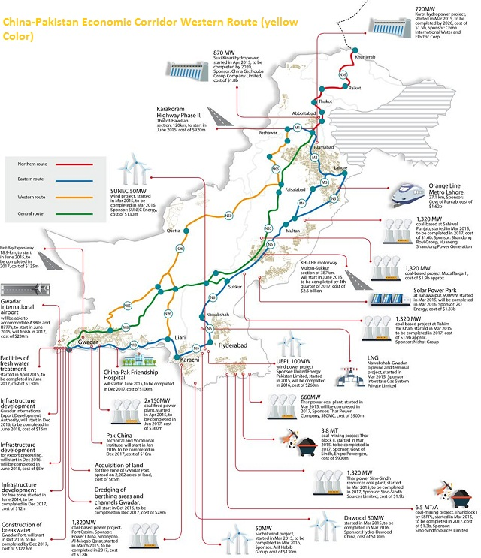
Major projects of the CPEC in Pakistan

Source: Khan, Shehryar & Liu, Guijian. (2019). Khan, Shehryar & Liu, Guijian. (2019). Socioeconomic and Public Policy Impacts of China Pakistan Economic Corridor on Khyber Pakhtunkhwa. Environmental Management and Sustainable Development. 8. 57. 10.5296/emsd.v8i1.13758.
Pakistan enjoys a significant geopolitical importance in the region as it is located near the two emerging economic giants China and India. With the strengthening trade relations between China and Pakistan through CPEC, the Pak Indian disputes may exacerbate and some of the recent steps taken by India in recent past have endorsed this fact. Some critics also argue that India and US view Gwadar as China’s naval base, to strengthen its military presence in the region. This negative propaganda is an attempt to jeopardize the CPEC.
Despite of negative publicity against CPEC, there is no doubt in the fact that CPEC will offer economic, cultural, and regional connectivity prospects for the countries, which will reshape geopolitics of the region and forge new alliances. China global trade has been suffering from many internal and external challenges, such as low domestic consumption, world economic shock, excessive production of infrastructure material and higher costs of labor. The New Normal of China international trade is based on reviving the old Silk Roads. The high reliance of China manufacturing on imported crude oil through the Malaccan Strait is becoming a major challenge for its trade growth and expansion. Under CPEC, China would like to mitigate its high dependence on one route. The length of the route will also be reduced from 12000 km to 3000 km via land from Gwadar to Kashghar. At the same time, China is faced with internal security threats from western region of Xinjian province. It is expected that with CPEC, this turbulent region will be provided with economic development and prosperity opportunities, which will ultimately lead to the durable peace in the region and progressively the anti-state sentiments will be resolved. Nevertheless, this unrest is one of the major challenges for CPEC as well.
Pakistan is faced with rampant energy shortfall and it is costing the national economy to the tune of $1.0 billion every year. It is estimated that by year 2030, the project will deliver additional 25,000 MW. This energy addition will boost the industrial sector of Pakistan, which will ultimately lead to value added exports and GDP growth. For internal security and national integration of Pakistan, CPEC will provide greater opportunities to the underprivileged regions of the country. Investments in the transportation, energy and Gwadar port, will generate employment and trade opportunities for the people of Baluchistan. The Special Economic Zones and Industrial Parks will be engine for economic growth of the country through rapid industrialization.
For boosting manufacturing sector and value added exports, the concept of Special Economic Zone is as old as 15th century but it got momentum after World War-II, when the first SEZs were established in Ireland and Taiwan. The term Special Economic Zone has been defined in many ways, which includes Free Trade Zones (FTZs), export processing zones (EPZs), Industrial parks (IP), economic and technology development zones (ETDZs), high-tech zones, science and innovation parks, free ports, enterprise zones etc. The two major benefits of SEZs is to create jobs for the local people and skill upgrading, transfer of high technology and innovation, economic diversity, enhancement of local firm’s productivity. The SEZs are established mainly for the four policy objectives:

i. Generating and attracting of foreign direct investment (FDI);
ii. Employment generation for locals to alleviate large-scale unemployment;
iii. Support for economic reforms on a large scale;
iv. Establishment of laboratories to test new policies and strategies for sustainable economic growth.

For success of SEZs, strong support and commitment from Government is required in terms of availability of land and other resources, incentives for investment such tax subsidies and rebates, institutional autonomy, strategic location on the supply chain routes, provision of onsite and offsite infrastructure such roads, utilities and water etc. Under the CPEC project in Pakistan 9 SEZs are being established. These SEZs are being established in view of the local expertise, availability of human and non-human resources, utilities, land and their connectivity with the CPEC and other important major highways.

Table: Details of nine major Special Economic Zones along CPEC in Pakistan:

S. No | Location of SEZs | Province | Brief outline
01 | Rashakai Economic Zone, M-1, Nowshera | Khyber Pakhtun-  khwa | The 1000 acres land-3 phases:  159 Acres-Phase-1, 279 acres in phase-II, 264 acres in Phase III  For commercial use, an area of 76 acres has been allocated.  Following Industrial potentials: -Garment and Textile Products, -Home Building Materials, General Merchandize, Electronics and Electrical Appliances,- Automobile and Mechanical Equipment
02 | Dhabeji Special Economic Zone | Sindh | 1530 acres of land to establish Dhabeji Special Economic Zone (DSEZ) in Thatta, will be developed in 3 phases.  Following Industrial potentials: Steel-Foundries, Automotive and Auto parts, Chemical & Pharmaceuticals, Consumer Electronics Engineering, Textile & Garments, Warehousing, Building Material  FMC
03 | Bostan Industrial Zone | Balochistan | Located near district Pishin Baluchistan over the area of 1000 acres. Following industry potentials : Fruit Processing, Agriculture machinery, Pharmaceutical, Motor Bikes Assembly, Chromite, Cooking Oil, Ceramic industries, Ice and Cold storage, Electric Appliance, Halal Food Industry
04 | Allama Iqbal Industrial City, Faisalabad | Punjab | 3217 acres land has been allocated near M-3.  Potential industries: Textile industry, pharmaceuticals, information technology, chemicals automotive, service complex.
05 | ICT Model Industrial Zone, Islamabad | Islamabad Capital Territory | Proposed over 200-500 acres, with the following potential industries:  T & related industries, Steel, Food Processing, Pharmaceutical & Chemicals, Printing and Packaging, Light Manufacturing
06 | Industrial Park Pakistan Steel Mills Port Qasim | Sindh | The zone covers the area of 1500 acres  Investments are encouraged in the following sectors: Steel, Auto & allied, Foundry and Fabrication, Warehousing & Logistics, Pharma, Chemical, Printing and Packaging, Garments etc.
07 | Mirpur Industrial Zone, AJK | AJK | 1078 acres of land in Mirpur district of AJK  Mix industry is proposed at Mirpur Industrial Zone
08 | Mohmand Marble City | Khyber Pakhtun-  khwa | 350 acres of land allocated for Marble city.  marble and other minerals including Uranium, dimensional stones, granite, coal, marble, manganese ore, limestone.
09 | Moqpoondas SEZ  Gilgit-Baltistan | GB | Closely located to the KKH/CPEC route, airport and Sost dry port.

Pakistan is regarded as one of the most attractive countries for FDI due to many factors such as geo-strategic location, young and highly skilled workforce with English proficiency, positive economic outlook with sustainable economic growth, friendly investment policy. Government of Pakistan and Board of Investment (BoI), have announced special incentives for these SEZs, which include one-time exemption from all customs duties and taxes on plant and machinery imported into Pakistan except the items listed under Chapter 87 of the Pakistan Customs Tariff. The zone developers also exempted from all kind of taxes for five years.
These SEZs are also faced with many internal and external challenges, such as terrorism, poor governance and large-scale corruption, chaotic law and order situation, difficulties in land acquisition, lack of consensus among federating units, water scarcity, red tapism in the way of zone development, etc. This will always a major challenge for the successive Government to overcome these challenges, through national consensus. In past, lack such mega projects have been jeopardized due internal political frictions. In the geopolitical dynamics, the success of CPEC and SEZs & IPs is critical for the development of the country.

Hideo Ohashi (2018) The Belt and Road Initiative (BRI) in the context of China’s opening-up policy, Journal of Contemporary East Asia Studies, 7:2, 85-103.
China National Development and Reform Commission (2015)
Chin, H. (2015). The Silk Road Economic Belt and the 21st Century Maritime Silk Road, Report by Fung Business Intelligence Centre.
Yafei. H. (2015). Connecting the World Through “Belt & Road”. China-US Focus.
Yuang, Bernard. 2017. One Belt, One Road: A Golden Opportunity for ASEAN
State Council. (2016). 13th five-Year plan for national informatization
Bora LY (2020) Challenge and perspective for Digital Silk Road, Cogent Business & Management, 7:1
Ishaan Tharoor, “What China and Pakistan’s special friendship means,” The Washington Post
Matthew McCartney (2021) The prospects of the China–Pakistan Economic Corridor (CPEC): the importance of understanding western China, Contemporary South Asia, 29:3.
Hamid, N., and S. Hayat. 2012. “The Opportunities and Pitfalls of Pakistan’s Trade with China and Other Neighbors.” The Lahore Journal of Economics 17 (SE): 271–292
Ahmad, D. 2017. “The China Pakistan Economic Corridor: Review and Analysis.” In The State of the Economy: China Pakistan Economic Corridor Review and Analysis, 49–64
Mehmood Hussain, Ahmed Bux Jamali (2019)-Geo-Political Dynamics of the China–Pakistan Economic Corridor: A New Great Game in South Asia- Chinese Political Science Review (2019) 4:303–326
AazarTamana, United States-Pakistan Relations in the Post-Cold War Era: The Pressler Amendment and Pakistan’s National Security Concerns, (Perth: Australian Society for South Asian Studies (ASSAS), 2004)
Douglas Zhihua Zeng, “How Do Special Economic Zones and Industrial Cluster Drive China’s Rapid Development,” in Building Engines for Growth and Competitiveness in China: Experience with Special Economic Zones & Industrial Clusters, ed. Douglas Zhihua Zeng, (World Bank), 2010, 4-5
CPEC Special Economic Zones, Ministry of Planning, Development and Special Initiatives. Available at http://cpec.gov.pk/special-economic-zones-projects

